Implement webpack for a project
https://github.com/Direct-Entry-Program/hello-webpack
link for clone the project
01. Install dependencies –> npm install
02. Install webpack as dev dependency,
because webpack is a build system. No need this in production. Just for development.
Need to check version of webpack first.
> npm i -D webpack (until version 4)
> npm i -D webpack webpack-cli (after version 4)
03. need to start webpack
method 1 - can run using npx
method 2 - add script to package.json and run script object in terminal
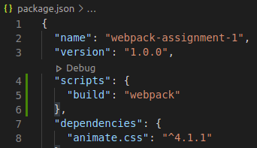

> npm run build
generated an error – no src directory

Assignment 01
01. npm install
02. install webpack > npm i -D webpack webpack-cli
03. cretae two js file for production and developing
for production → webpack.config.dev.js
for developing → webpack.config.prod.js
04. add “scripts” to package.json
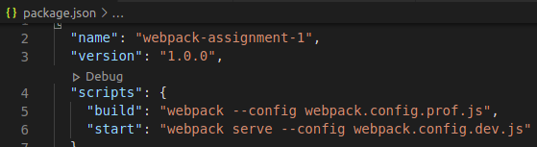
serve – for start dev server
05. Define entry point → add index.js
06. add module exports in webpack.config.prod.js
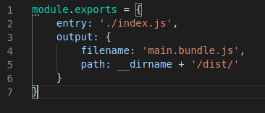

07. import main script in js folder to index.js
import './js/script.js';
08. Export and import functions and variables required between js files
Ex:-
export function typeWritingAnimation() {
--------------------------------------------------------------------
import {typeWritingAnimation} from './type-writing-animation';

-------------------------------------------------------------------
export var title = document.querySelector("h1");
export var texts = []; // Stores all the typewriting animation texts
export var k = 0; // An increment
export var j = 0;

--------------------------------------------------------------------
import {k, texts, title, j} from './script';
09. run > npm run build
creates dist folder and main.bundle.js (output which mention in webpack.config.prod.js)
10. link javascript to index.html
11. compete css styles
need → sass loader, css loader, minicss extract plugin
plugin → webpack.js.org → documentation → plugins
sass was globaly installed, but need to install here also
install as dev dependencies
> npm i -D sass-loader sass css-loader mini-css-extract-plugin
12. add module rules to webpack.config.prod.js
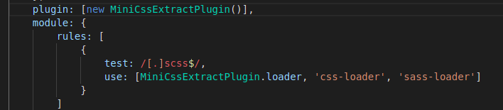
we need to add plugings to the plugin array
meaning of this –> test if find sass files and use this loaders for that file
13. import scss/style.scss file to index.js
14. Rename css file name from passing option in plugin array
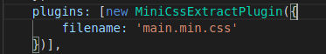

15. need to install clean-webpack-plugin to clear the previous css file
Documentation → guide → output management → cleaing up/dist
> npm install --save-dev clean-webpack-plugin
add to plugin array

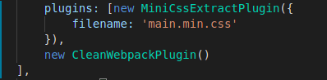

16. change the link of style sheet in index.html file to “./dist/main.min.css”
17. This is not suitable link node_modules like this,
<link rel="stylesheet" href="node_modules/animate.css/animate.min.css">
-check whether load path is available to import this to style.scss file
- if there is no load path, get the relative path required location and import like below
@import 'node_modules/animate.css/animate.min.css';
alternative for “node_modules”
@import '~animate.css/animate.min.css';
18. need to create dev server in webpack.config.dev.js
copy all content of prod.js to dev.js
-no need clean webpack plugin here
- additionaly need the dev server → install as dev dependency
> npm i -D webpack-dev-server
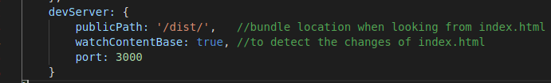
> npm start

